🔹 What is Procedural Programming?
Procedural Programming is a programming style where a program is written as a sequence of step-by-step instructions (procedures or functions).
It focuses on:
- Functions (procedures)
- Step-by-step execution
- Data is passed between functions

🔹 What is Object-Oriented Programming (OOP)?
Object-Oriented Programming (OOP) is a programming paradigm where we design software using objects instead of step-by-step procedures.
It focuses on:
- Objects (real-world entities)
- Data (state)
- Behavior (methods)
👉 In OOP, data and functions are combined inside objects.

🔹 Difference between Procedural and OOP Programming
Procedural Programming | Object-Oriented Programming
Focus on functions | Focus on objects
Data and functions are separate | Data and functions are combined
Hard to manage large programs | Easier to manage large programs
Code is less reusable | Code is reusable
Example: function(data) | Example: object.method()
👉 Procedural = “What steps to do”
👉 OOP = “Who does what”

🔹 Why do we need OOP?
We need OOP because in large programs:
- Data and functions become difficult to manage in procedural programming
- Code becomes messy and hard to maintain
- It is difficult to track which function modifies which data
OOP solves these problems by:
- Combining data and behavior in one unit (object)
- Making code more organized and reusable
- Making large systems easier to manage

🔹 What is a Class?
A Class is a blueprint of an object that are used to create an objects. It does not exist physically in memory as data
It defines:
- What data an object will have (attributes)
- What actions an object can perform (methods)
Example: Blueprint of a house
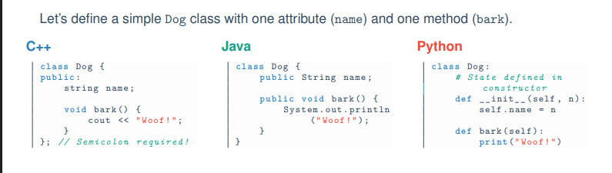
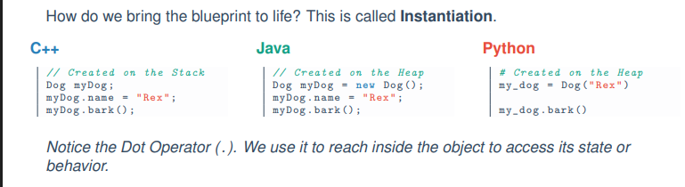

🔹 What is an Object?
An Object is a real instance of a class.
- It is created from a class
- It exists in memory (RAM)
- We can create multiple objects from one class
Example: Actual houses built from the same blueprint

🔹 Difference between Class and Object
Class | Object
Blueprint or design | Real instance
Does not occupy memory | Occupies memory
Logical concept | Physical existence in program
Defines structure | Holds actual data

1.3 State and Behavior (Clean & Exam-Ready)
An Object in Object-Oriented Programming is a software entity that combines two important parts: State and Behavior.

🧠 1. State (Attributes / Data)
State means what the object is or what it knows.
- It represents the data or properties of an object
- It is stored using variables (attributes) inside the object
👉 Example (Dog object):
- name = Bruno
- breed = Husky
- age = 3
- color = Brown
✔ So, state describes the current information of an object.

⚙️ 2. Behavior (Methods / Logic)
Behavior means what the object can do.
- It represents the actions or functions of an object
- It is defined using methods (functions inside the class)
👉 Example (Dog object):
- bark()
- eat()
- sleep()
✔ So, behavior describes the actions or functionalities of an object.

🔹 What is a Custom Data Type?
A Custom Data Type is a user-defined data type created by programmers when built-in data types (like int, float, char, boolean) are not enough to represent real-world objects.

🧠 Simple Explanation:
Computers already provide basic data types:
- int → numbers
- float → decimal numbers
- boolean → true/false
These are called primitive data types.
But in real life, we often deal with complex entities.

🏗️ Why do we need Custom Data Types?
For example, consider a Student.
A student has:
- Name (string)
- ID (int)
- GPA (float)
👉 These values belong to one entity but are of different types.
So, instead of managing them separately, we create a new type called:
👉 Student (Custom Data Type)

💡 Class = Custom Data Type
When we create a class, we are actually defining a new custom data type.

Example:
class Student {
public:
string name;
int id;
float gpa;
};
👉 Here, Student is a custom data type created by the programmer.

Stacks:
A stack is a list of elements in which an element may be inserted or deleted only at one end, called the top of the stack.
Two basic operations associated with stacks:
“Push” is the term used to insert an element into a stack.
“Pop” is the term used to

Memory in a computer program is mainly divided into two parts: Stack and Heap. These two areas are used to store different types of data during program execution.

1. Stack Memory
The Stack is a small, fast, and structured area of memory used for storing local variables and function calls.
- It follows the LIFO (Last In, First Out) principle.
- Each time a function is called, a new block (called a stack frame) is created.
- When the function finishes execution, its allocated memory is automatically removed.
Characteristics:
- Very fast access ⚡
- Limited in size
- Automatically managed (no need for manual deallocation)
- Stores primitive data types and local variables
Example:
void MyFunction() {
int x = 10;
int y = 20;
}
Here, x and y are stored in the Stack.

2. Heap Memory
The Heap is a large and unstructured area of memory used for dynamic memory allocation.
- Objects and data created at runtime are stored in the Heap.
- Memory is allocated manually (or by using new) and managed by the Garbage Collector in languages like C#.
Characteristics:
- Slower than Stack 🐢
- Much larger in size
- Used for storing objects and complex data
- Requires memory management (automatic in .NET via Garbage Collector)
Example:
Student s = new Student();
Here, the object is stored in the Heap, while the reference variable s is stored in the Stack.

3. Difference Between Stack and Heap
Feature | Stack | Heap
Speed | Very fast | Slower
Size | Small | Large
Memory Management | Automatic | Manual / Garbage Collected
Data Stored | Local variables, primitives | Objects, dynamic data
Structure | Organized (LIFO) | Unstructured

Conclusion
In summary, the Stack is used for temporary data like function calls and local variables, while the Heap is used for dynamic memory allocation such as objects. Understanding the difference between them is essential for efficient memory management and programming.

When you write Dog d1 = new Dog(); in Java (or d1 = Dog() in Python), what is d1?
In conclusion, d1 is a reference variable stored in Stack memory, which holds the address of a Dog object located in Heap memory. The actual object data is stored in the Heap and all operations on the object are performed through the reference variable.
In the statement Dog d1 = new Dog();, d1 is a reference variable (or pointer), not the actual object.
- The actual Dog object is created in the Heap memory.
- The reference variable d1 is stored in the Stack memory.
d1 stores the memory address (reference) of the object created in the Heap.
Step 1: Object Creation
new Dog();
- A new Dog object is created in the Heap memory.
- Memory is allocated for its data (e.g., name, age).
Step 2: Reference Assignment
Dog d1;
- A variable d1 is created in the Stack memory.
- This variable is capable of storing a reference (address).

Step 3: Linking Stack and Heap
Dog d1 = new Dog();
- The address of the Dog object (e.g., 0x8F) is stored inside d1.
- So, d1 now points to the object in the Heap.
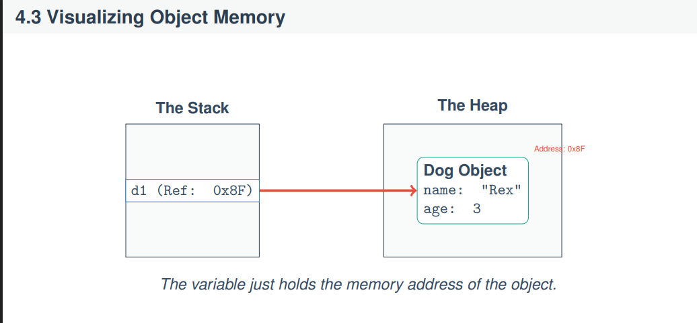

Left Side (Stack)
- There is a variable:
d1 (Ref: 0x8F)
- This means d1 is storing the address 0x8F

Right Side (Heap)
- At address 0x8F, there is a Dog object
- It contains:
  - name = "Rex"
  - age = 3
What happens if we copy a reference?
Here is a clear, well-organized exam-ready answer for “The Danger of Aliasing” 👇

The Danger of Aliasing

✅ Definition
Aliasing occurs when two or more reference variables point to the same object in memory (Heap).
In such cases, any change made through one reference affects the same object seen by the other reference.

Given Code
Dog d1 = new Dog();
d1.name = "Rex";

Dog d2 = d1; // Reference copy (Aliasing)

d2.name = "Max";

System.out.println(d1.name);

Step-by-Step Explanation

🔹 Step 1: Object Creation
Dog d1 = new Dog();
- A Dog object is created in the Heap.
- d1 (in Stack) stores the reference (address) of that object.

🔹 Step 2: Assign Value
d1.name = "Rex";
- The object's name property becomes "Rex".

🔹 Step 3: Reference Copy (Aliasing)
Dog d2 = d1;
- No new object is created ❌
- Only the reference is copied ✔️
- Now, both d1 and d2 point to the same object in Heap

🔹 Step 4: Modify Using Second Reference
d2.name = "Max";
- The same object is updated
- So the name becomes "Max"

🔹 Step 5: Output
System.out.println(d1.name);
👉 Output will be: Max

Why Output is “Max”?
Because:
- d1 and d2 are pointing to the same object
- Changing the object through d2 also affects what d1 sees

Important Concept
👉 No new object is created during Dog d2 = d1;
👉 Only the reference (memory address) is copied
👉 This leads to aliasing

Real-Life Analogy
- d1 = Remote Control 1 📺
- d2 = Remote Control 2 📺
- Object = TV
➡️ Both remotes control the same TV
➡️ Changing channel with d2 also affects what d1 sees

C++ is Different (Pass by Value by Default)

✅ Main Concept
In C++, objects are stored directly in Stack memory by default, and copying a variable creates a complete duplicate (clone) of the object, not just a reference.

1. Object Creation in C++
Dog d1;
- A Dog object is created directly in the Stack memory
- No Heap allocation is involved here

2. Object Copy (Pass by Value)
Dog d2 = d1;
- A new separate object d2 is created
- C++ performs a deep copy (physical clone) of d1
- Now, d1 and d2 are completely independent objects
👉 Changing d2 will NOT affect d1

What is Encapsulation?
Encapsulation is one of the fundamental concepts of Object-Oriented Programming (OOP).
It means bundling data (variables) and methods (functions) together into a single unit called a class, and restricting direct access to some parts of that data.

⭐ Why do we use Encapsulation?
We use encapsulation to protect the Object Invariant.

🔹 What is an Invariant?
An invariant is a rule or condition that must always remain true for an object to be valid.
If this rule breaks, the object becomes invalid or incorrect.

Example (Bank Account)
Think about a Bank Account:

❌ Without Encapsulation (Bad Design)
If balance is public, anyone can do this:
- balance = -999999 ❌ (invalid)
- balance = "Potato" ❌ (meaningless)
This breaks the rules of a real bank account.

Access Modifiers:
Access Modifiers are keywords used in Object-Oriented Programming to control the visibility (access level) of class members such as variables and methods.
👉 In simple words:
They decide who can see or use the data inside a class.

Why do we use Access Modifiers?
We use access modifiers to enforce Encapsulation.
👉 Encapsulation ensures that data is protected and cannot be accessed directly from outside the class.
Access modifiers help by:
- hiding sensitive data
- controlling how data is accessed or modified
- improving security and data integrity

1. Public (public)

Meaning:
- Accessible from anywhere
- Outside the class can read and modify it

Usage:
- Usually used for methods (behaviors)

Example idea:
If something is public, anyone can use it freely.
👉 Like: ATM machine buttons (withdraw, deposit)

2. Private (private)

Meaning:
- Accessible only inside the same class
- No outside access allowed

Usage:
- Usually used for variables (state/data)

Example idea:
If something is private, only the owner can control it.
👉 Like: ATM internal account balance (you cannot directly change it)

Getters and Setters:
When class variables are declared as private, they cannot be accessed directly from outside the class.
So, we use special public methods called Getters and Setters to safely access and modify those private variables.
class Student {
private String name; // private variable
// Setter method (value set করার জন্য)
public void setName(String name) {
this.name = name;
}
// Getter method (value পাওয়ার জন্য)
public String getName() {
return name;
}
}

public class Main {
public static void main(String[] args) {
Student s1 = new Student();
s1.setName("Rahim");
System.out.println(s1.getName());
}
}

🔐 Why do we need Getters and Setters?
Because of Encapsulation:
- Data is kept private (hidden)
- But we still need controlled access
- So we use public methods as “gatekeepers”

📌 1. Getter Method (Read Access)

Meaning:
A getter is a method used to read or get the value of a private variable.

Features:
- Only returns value
- Does NOT modify data
👉 Think: “I want to see the value”

📌 2. Setter Method (Write Access)

Meaning:
A setter is a method used to change or update the value of a private variable.

Features:
- Can include rules/validation
- Controls how data is updated
👉 Think: “I want to change the value safely”
💻 Example (Bank Account)
class BankAccount {
private double balance = 0; // Hidden data

// Getter → Read balance
public double getBalance() {
return balance;
}

// Setter → Controlled update (deposit)
public void deposit(double amount) {
if (amount > 0) {
balance += amount;
}
}
}

Why not just make it public?
If we make all data public, it becomes very easy to access and modify it directly.
But this breaks Encapsulation and can lead to invalid or unsafe data.
So instead, we use private data + public methods to control access.

🧠 Vending Machine Analogy
This is the best way to understand it:

❌ Public Data (Bad Design)
Imagine a vending machine where everything is open:
- You can directly take chips without paying
- Anyone can open the machine and change items
- No rules are enforced
👉 Result:
- No security
- No control
- System becomes useless

🔐 Private Data + Methods (Good Design)
Now imagine a proper vending machine:
- The items are inside a locked glass box
- You cannot directly touch them
- You must use buttons and coin slot

How it works:
- You insert money
- You press a button
- Machine checks payment
- Machine gives item
👉 The machine enforces all rules automatically

💡 Connection to Programming

Public variables:
- Anyone can change data directly
- No validation
- Risk of invalid values

Private variables + methods:
- Data is hidden
- Access only through methods
- Rules are always checked

Encapsulation in Python (Easy Version)

Step 1: What is Encapsulation?
Encapsulation = hiding internal data of a class so that it cannot be accessed directly from outside.
- Helps protect data.
- Only certain methods can access or modify it.
Think of it like a bank vault:
- You can deposit or withdraw money through a controlled system.
- You cannot directly touch the money inside.

Step 2: How Python Does Encapsulation
- Python does not have strict private or public keywords like Java or C++.
- Instead, Python uses a naming convention to indicate private variables.
Rule:
- Prefix a variable with __ (double underscore) → makes it “hidden”
Example:
class BankAccount:
def __init__(self):
self.__balance = 0
def deposit(self, amount):
if amount > 0:
self.__balance += amount

Step 3: Accessing Hidden Variables
- You should not access __balance directly outside the class.
- Instead, you use methods to interact with it.
account = BankAccount()
account.deposit(100) # Correct way
print(account.__balance) # ❌ This will give an error

6.1 The Birth of an Object (Python Version)
When we write:
my_dog = Dog()
Two things happen:
- Memory allocation: Python asks the OS for memory to store the object.
- Constructor call: Python automatically runs a special method called the constructor.

Step 2: What is a Constructor?
Definition:
A constructor is a special method that is automatically called when an object is created.
Purpose:
- Initialize the object’s state (set starting values for variables)
- Ensure the object starts in a valid state
Think of it as giving a baby a name and some clothes right after birth—the object is ready to use.

6.2 Constructor Syntax

In C++ / Java
- Name: Same as the class name
- Return type: None (not even void)
- Example (Java):
class Student {
private String name;

// Parameterized Constructor
public Student(String startingName) {
name = startingName;
System.out.println("A student is born!");
}
}

// Usage:
Student s1 = new Student("Alice"); // Must provide a name

In Python
- Name: Always __init__
- No need to declare variables before using them; just use self.variable = value
Example:
class Student:
# Constructor
def __init__(self, starting_name):
self.name = starting_name
print("A student is born!")

# Usage
s1 = Student("Alice")
Notes:
- self refers to the current object
- Assigning self.name = starting_name creates the attribute dynamically

Default Constructors

Step 1: What is a Default Constructor?
- A default constructor is a constructor with no arguments.
- If you don’t write any constructor, the compiler automatically provides one (C++/Java).
- Its job: initialize variables to default “zero values”:
  - 0 for numbers
  - null for objects
  - false for booleans

Step 2: Example in Java/C++
Without writing a constructor:
class Student {
private String name;
private int age;
}
// Usage:
Student s1 = new Student(); // Default constructor is automatically used
- Here, name = null and age = 0 by default.

Step 3: Custom Constructor Effect
- If you write any constructor yourself, e.g.:
public Student(String name) {
this.name = name;
}
- Then the compiler removes the default constructor

When it works
- Works only if there is a constructor that takes no arguments.
- If you didn’t write any constructor at all, the compiler automatically provides a default constructor (no-arg). ✅ Works
Example:
class Student {
private String name;
}
Student s2 = new Student(); // ✅ Works, compiler provides default constructor

When it gives ERROR
- You wrote a custom constructor with arguments but did not write a no-argument constructor.
Example:
class Student {
private String name;
// Custom constructor with argument
public Student(String name) {
this.name = name;
}
}
// Now:
Student s2 = new Student(); // ❌ ERROR: no default constructor available
Reason:
- As soon as you write any constructor, the compiler does not create the default no-argument constructor.
- So new Student() cannot find a matching constructor → compile-time error.

The Death of an Object (Destructors)

Step 1: What happens when we’re done with an object?
- An object takes memory when created.
- Once we don’t need it anymore, its memory should be freed to avoid waste.
- This is called destruction of the object.

Step 2: How different languages handle it
✅ 🔹 English Version (Short Exam Answer)
Garbage Collection is an automatic memory management process that removes unused or unreachable objects from the heap memory.
In languages like Java and Python, objects are stored in heap memory and accessed through references. When an object no longer has any reference, it becomes unreachable, and the garbage collector automatically deletes it to free memory.
In contrast, C++ does not support automatic garbage collection. The programmer must manually deallocate memory using delete, otherwise memory leaks may occur.

✅ 🔹 Bangla Version (Short Exam Answer)
Garbage Collection হলো একটি automatic memory management process, যেখানে unused বা unreachable object গুলোকে heap memory থেকে সরিয়ে ফেলা হয়।
Java এবং Python এ object গুলো heap memory তে থাকে এবং reference এর মাধ্যমে access করা হয়। যখন কোনো object এর আর কোনো reference থাকে না, তখন সেটি unreachable হয়ে যায় এবং garbage collector সেটিকে automatically delete করে memory free করে।
অন্যদিকে, C++ এ automatic garbage collection নেই। Programmer কে manually delete ব্যবহার করে memory free করতে হয়, না হলে memory leak হতে পারে।

1️⃣ C++ (Manual Memory Management)
- If you created an object on the heap:
Dog* myDog = new Dog();
- You must delete it manually:
delete myDog; // Calls destructor ~Dog() automatically
- Destructor (~Dog()): a special method that cleans up resources (memory, files, etc.) before the object is removed.

Java / Python (Automatic Garbage Collection)
- You do NOT delete objects manually.
- The interpreter/VM tracks references:
  - If no variable points to the object, it’s unreachable.
- Garbage collector automatically deletes it and frees memory.
Example in Python:
class Person:
def __init__(self, name):
self.__name = name # private variable

def set_name(self, name):
if isinstance(name, str) and name.strip() != "":
self.__name = name
else:
print("Invalid name!")

def get_name(self):
return self.__name
# When the function ends, myDog has no references
# Garbage Collector removes the object automatically
- No need to write destructors like in C++

Step 3: Key Points for Exam
- C++: Manual deletion (delete) → destructor called
- Java/Python: Automatic deletion → garbage collector frees memory
- You rarely write destructors in Java/Python

How Methods Know Which Data to Use

Step 1: The Situation
You have:
Dog d1 = new Dog("Rex");
Dog d2 = new Dog("Max");
d1.bark(); // Rex says Woof!
d2.bark(); // Max says Woof!
- Notice there is only one copy of bark() code in memory.
- But somehow, it uses d1’s name in one call and d2’s name in another.

Step 2: The Trick
- Every object keeps its own copy of its data (attributes) in memory.
  - d1 has name = "Rex"
  - d2 has name = "Max"
- The method doesn’t store the data itself. Instead, it knows which object is calling it.

Step 3: The Magic Word: this
- In most OOP languages, a special hidden reference exists called this (Python: self).
- this points to the current object that called the method.
class Dog {
String name;
public Dog(String name) {
this.name = name;
}
void bark() {
System.out.println(this.name + " says Woof!");
}
}

The Hidden Parameter
Definition:
যখন আমরা কোনো অবজেক্টের মেথড কল করি, কম্পাইলার গোপনভাবে সেই অবজেক্টের মেমোরি ঠিকানা পাঠায় মেথডে। এই লুকানো প্যারামিটারকে this (Java/C++) বা self (Python) বলা হয়।
Example (Java/Python):
Dog d1 = new Dog("Rex");
d1.bark(); // What we write
// Actually executed by compiler:
Dog_bark(d1); // Hidden parameter passed

this (C++/Java) and self (Python)
Inside the method, we have access to this hidden parameter
Python makes this explicit. You MUST write self as the first parameter. C++/Java makes this implicit. The keyword this is always available in the background.

Python
def bark(self):
print(self.name + " says Woof!")
# self is d1

Java
public void bark()
{
System.out.println(this.name + " says Woof!"); // ’this’ is implied, but you can write it.
}
Using this to resolve ambiguity:
The most common use of this in Java/C++ is when parameter names clash with attribute names.

class Student{
private String name; // Attribute
public Student(String name){ // Parameter // name = name; // Bug! Assigns parameter to itself.
// Fix: Use ’this’ to point to the Object’s attribute.
this.name = name;
}
}
Defining the Rules (Invariants):
Before coding, define the rules your Class must protect:
Rule1: Awallet cannot have a negative balance.
Rule2: Youcannot send more money than you have.
Rule3: The owner’s name is set at birth (constructor) and cannot be changed later.
These rules dictate our Encapsulation strategy. ‘balance‘ must be private. ‘owner‘ must have no setter method.
baki problem er solution gulo shhet theke dekhe nebo.

